# **Instructions to create a New Project in CCSv10 for DSP TMS320F28379D**

* Before Starting, the latest version of the Code Composer Studio software should be downloaded/installed from <https://www.ti.com/tool/CCSTUDIO>.
* The following steps must be properly accomplished to start writing the C Code into the Software.
* 1. Creating a new Empty Project

File —> New —> CCS Project

Target: 2837xD Delfino TMS320F28379D

Connection: XDS100v2 USB Debug Probe

Project name: Any name without space, e.g., 2020_UTS_3p_inverter

2. From the project type and examples, An **Empty Project** has to be selected as given in below.

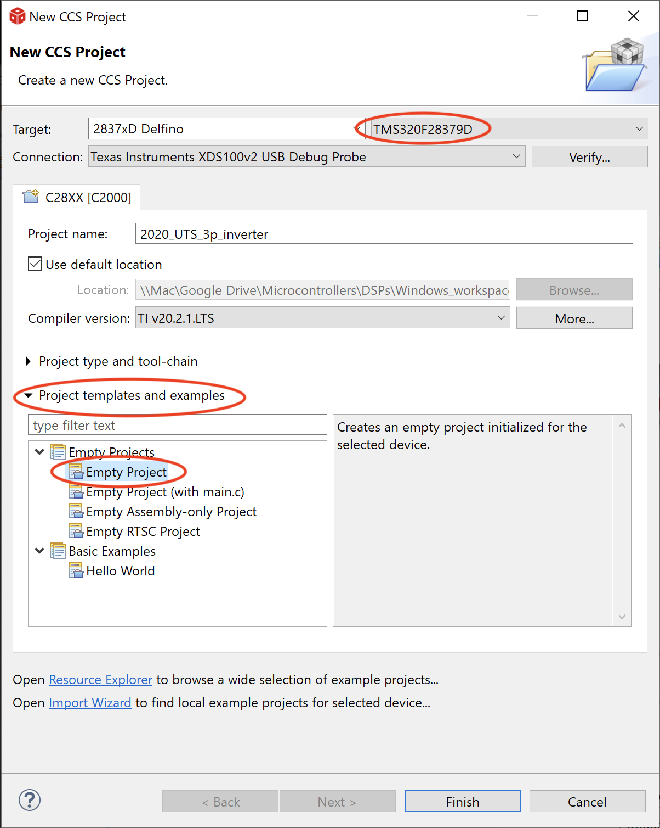

3. From the Project type and tool-chain, the Linker command File should be selected as “none” and select the “finish” bottom finally as given below.

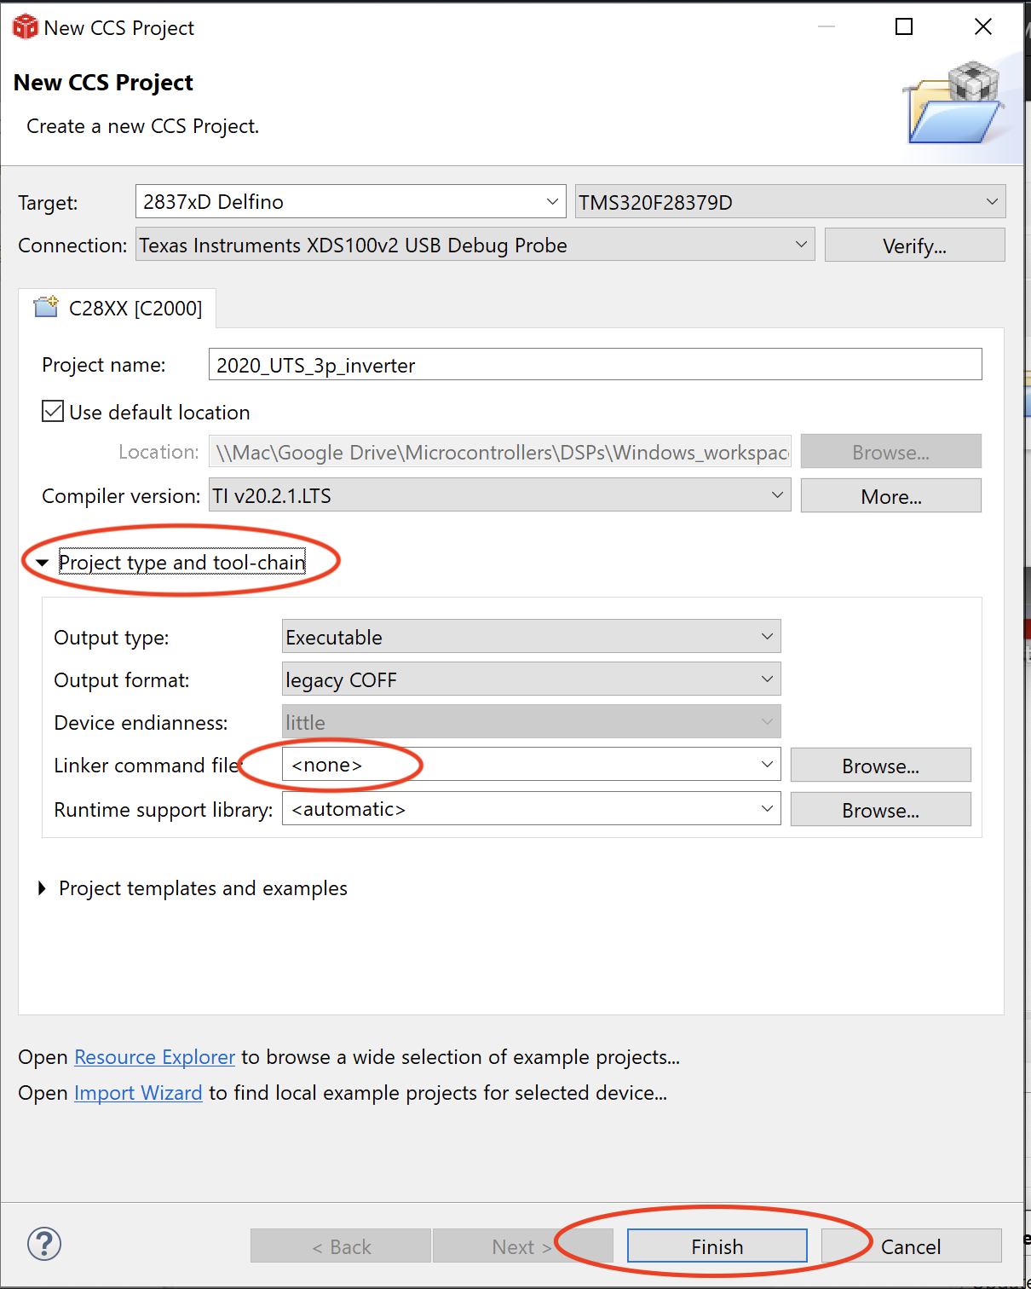

4. There are some files that must be added into the project. Therefore, right click on the project and select/drag **“all files”** from the folder of “UTS_F28379D/00_F28379D” as below:

Then in File Operation, select Copy files and click OK.

5. Now, right click over the project, and select “show build setting” and follow these steps:

5-1. In “General” tab and in “Variant” section fill the following:

**2837xD Delfino TMS320F28379D**

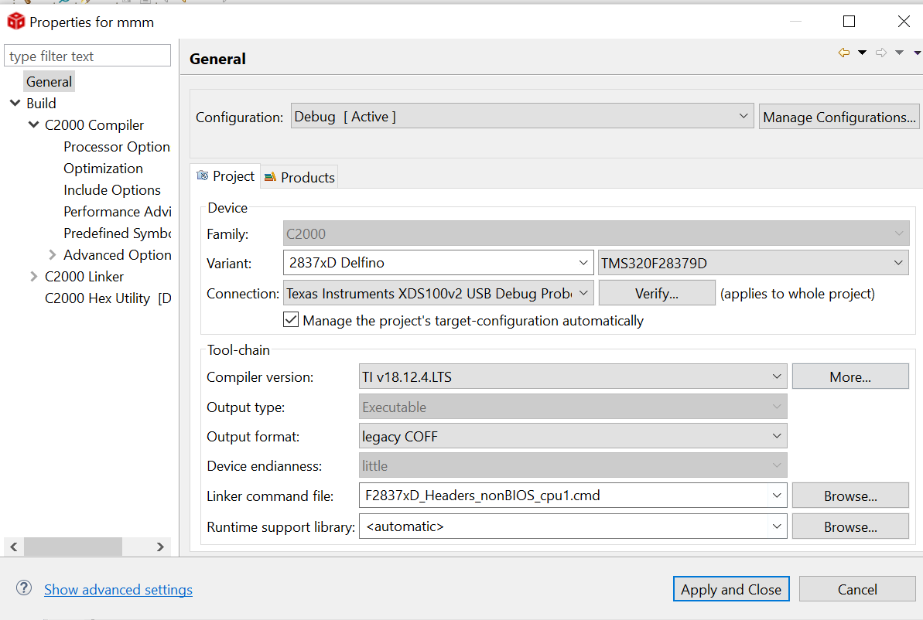

5-2. In the “Build” section, go through the C2000 Code Composer and select “Include” option as given below:

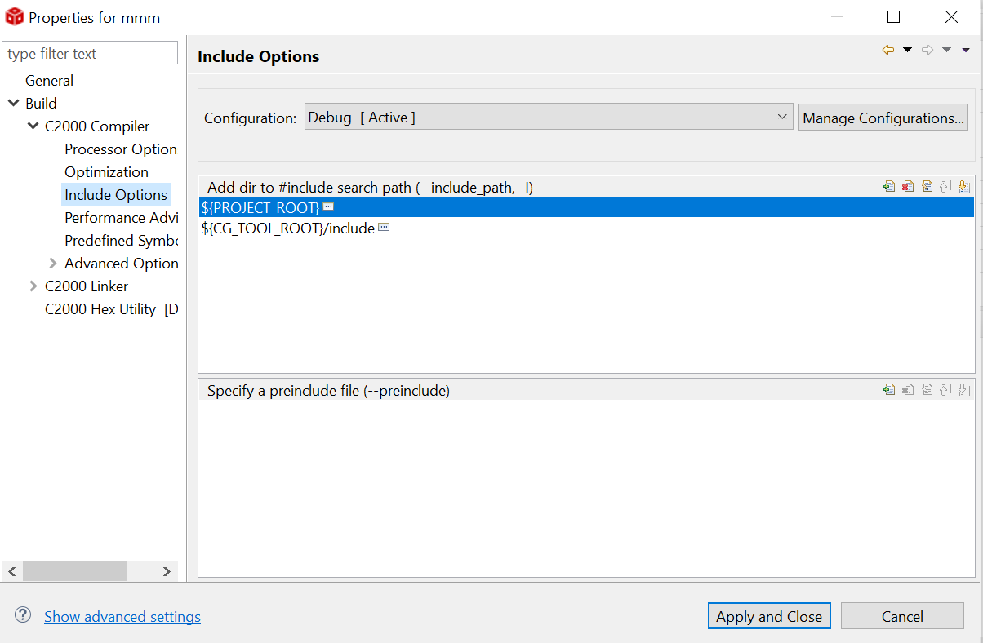

5-3. Select “add” from the right corner side and add the following path from the source folder:

…\00_Required_Files_F28379D\F2837xD_common\include

…\00_Required_Files_F28379D\F2837xD_headers\include

…\00_Required_Files_F28379D\F2837xD_UTS_includes_v0x

Therefore the tab of “Add dir to #include search path” must be filled as following image:

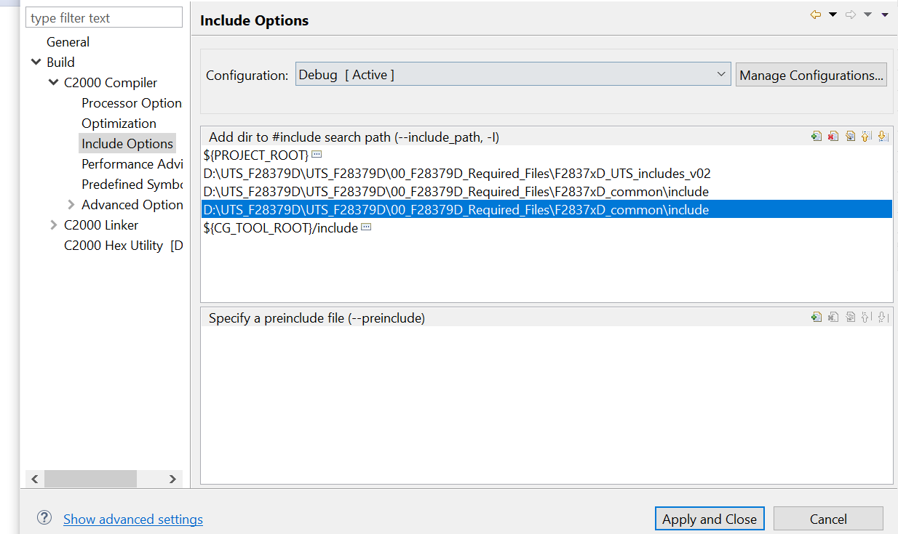

5-4. In the tab of “predefined symbols”, click “add” and write>>>CPU1<<< as follows:

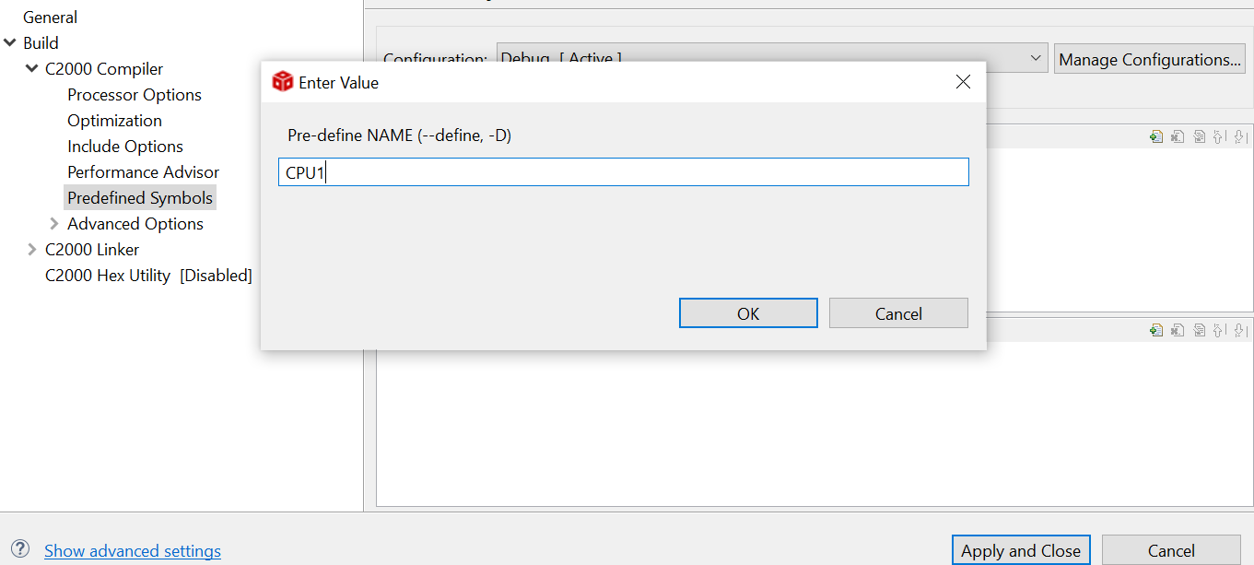

5-5 In the “optimization” tab, select **“relaxed”** in the **floating point mode** section as given below:

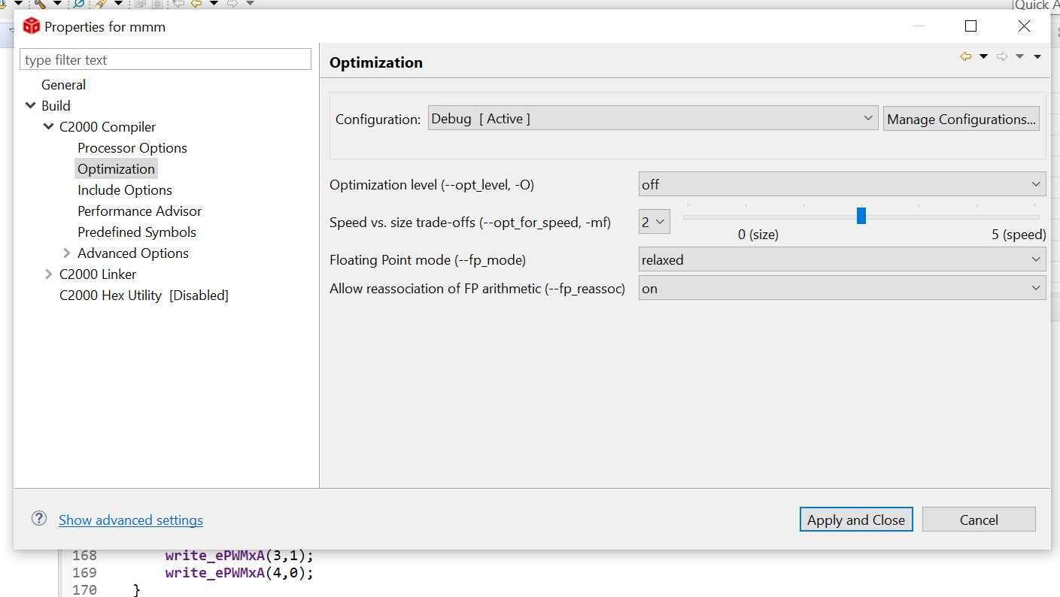

Now, project is ready for writing.